LOK JAGRUTI KENDRA UNIVERSITY
M.Sc. Cybersecurity Semester III
Mid Semester Practical Examination
Subject Code:340110306 Date: 27/10/2026
Subject Name: Ethical Hacking & Penetration Testing
Duration: 12:30 PM to 3:00 PM Total Marks: 10

NOTE: All the Practical’s are compulsory
- Mention Set number & Enrollment number in the answer sheet (If not written or wrong set number is written then answer sheet will not be evaluated and marked zero.)
- Also, only if the answers are correct then and then marks will be given
- Make sure no other documents apart from the necessary documents (which require during exam) for the exam should be open (If open then liable for the UFM)
- For the Viva, if student can’t answer the question, then 0 marks will be given by the invigilator/ viva taker.
- During exam, if student finds doing any copy paste from any document or taking help from the online medium then answer won’t be accepted and will get 0 marks for the whole exam (UFM)
- Students can write down the analysis according to the steps, make sure steps include technical words only (If not then marks will be given accordingly).
- Also Screen Shot should be appropriate as per the steps and important things must be highlighted in the Screenshot with the Timestamps (If not then marks will be given accordingly)
- Most Importantly, screenshots without proper visibility of timestamps will not be considered and the student can be liable to get 0 marks.
- If any students have just mentioned the Steps without appropriate Screenshots, then the question gets 0 marks.
- If the Browser history Screenshot before and after the exam is not there then marks will be deducted accordingly.
- Answer sheet will only be accepted in the google classroom submission (If students fail to submit on time due to any reason, they will get 0 marks)

SET - 2

ANSWER SHEET
Practical: 1

AIM: Perform SQL Injection testing on the DVWA (vulnerable web application). Identify the vulnerable parameter, analyze the application’s response to controlled input, demonstrate the SQL injection vulnerability in the authorized lan environment and determine its security impact. Explain the appropriate remediation techniques that should be implemented by the developer.

Procedure

Step 1: Start Machine and Check IP & Connection

First Start kali linux and Metasploitable2.
For finding both machine IP address run command: ifconfig on both.
Using ping command to check Metasploitable2 is response
ping -c 4 192.168.222.13
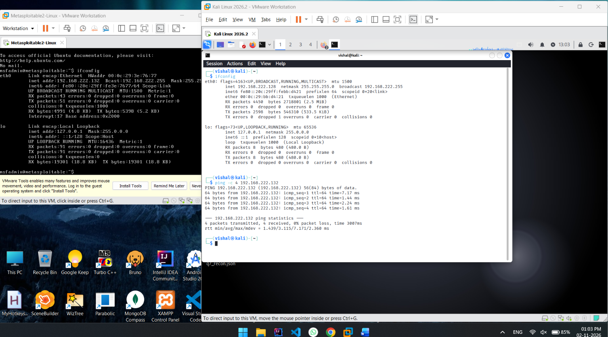
Figure 1: Both Machine IP Address and ping command
POC Explain
Here we see in screenshot Kali Linux IP address is 192.168.222.128
And Metasploitable2 IP address is 192.168.222.132
Ping command showing “0% packet loss” means Metasploitable2 is running correctly and connected.

Step 2: Login DVWA and ser Security Low

Now open any browser in Kali Linux and in url enter metasploitable2 ip address and click enter
Then, click on DVWA, now new page is showing login page, enter default credentials
Username: admin & Password: password then click login
Now, DVWA home page (index.php) is opened
Then, on left side panel click ‘DVWA Security’, and
then on right side ‘Script Security’ here change High to Low and click Submit.

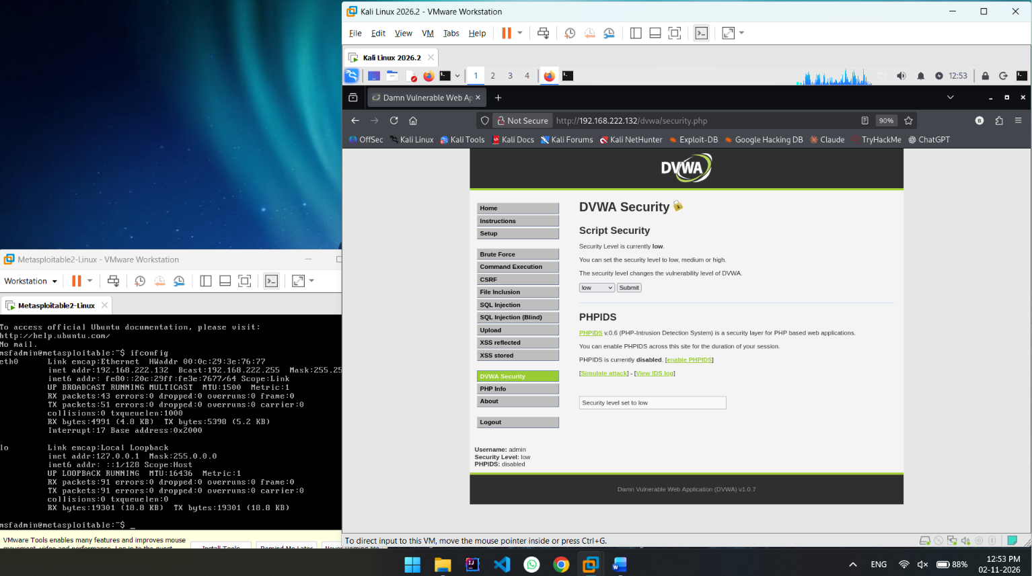
Figure 2: After DVWA login, then page shwing DVWA Security is Low
POC Explain

Here in screenshot we see DVWA security.php page is opened and Security is set as Low.

Step 3: SQL Injection Page Normal Flow
After Step 2, now on left panel click on ‘SQL Injection’
Then left side showing User ID: input box
Here enter any id like 1 then click Submit
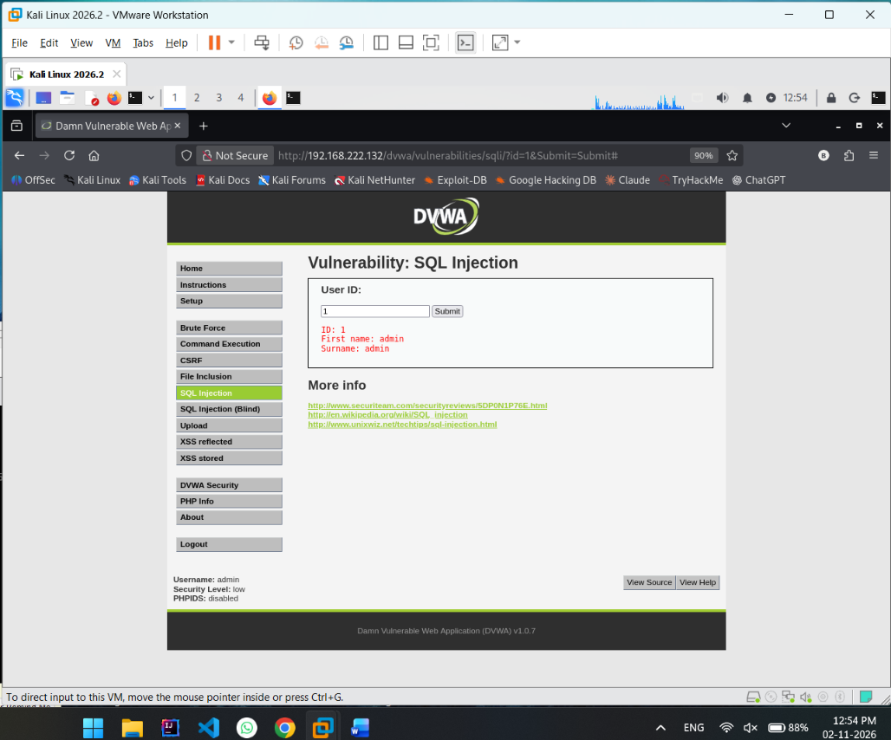
Figure 3: Normal Flow of get user information
POC Explain
In Screenshot showing normal frow of page,
here I am enter User ID ‘1’ then click Submit And I see
ID: 1
First name: admin
Surname: admin

Step 4: SQL Injection

Second time in User ID: input box enter bind sql query with parameter
1' UNION SELECT user, password FROM users-- -

Here in query UNION is working for merging and showing two table data in one response
1 is run as normal then UNION select user, password from users, is merge all user username and password and we see that on Response
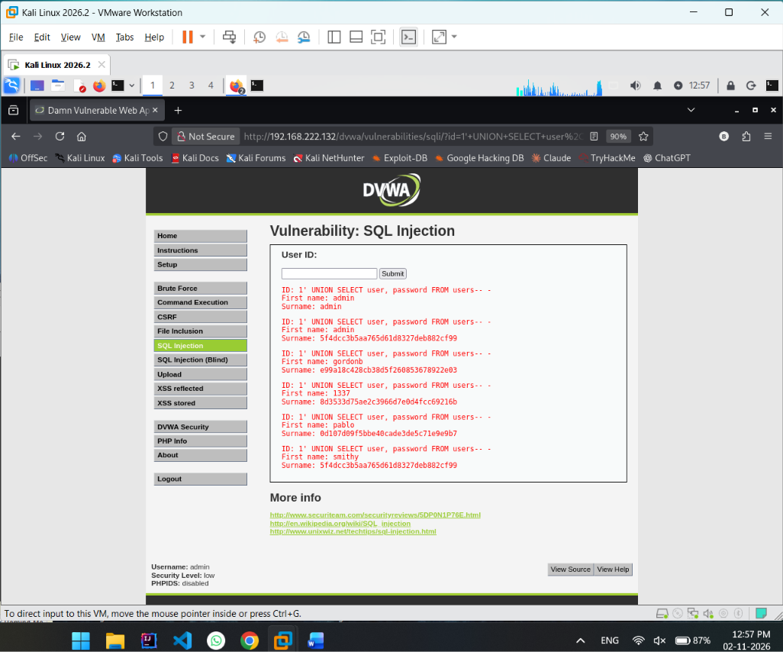
Figure 4: SQL Injection & all username or password
POC Explain
Here we see attacker enter query is 1' UNION SELECT user, password FROM users-- -
And response showing all user First name and surname but as per quesry select user, password from user, then First Name is username and Surname is Password Hash.

Step 5: Source Code
On DVWA page right bottom have button View Source code, click it
Now we see new windows showing source code of this page,
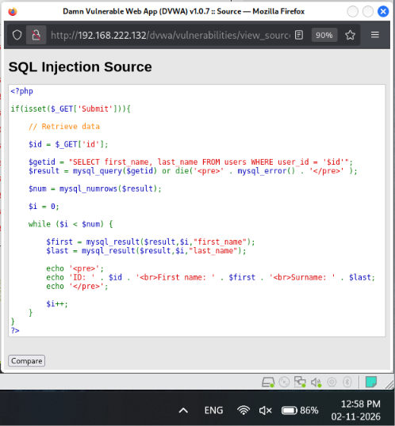
Figure 5: Source code of page
POC Explain
Here we see SQL Injection page source code
$getid = “SELECT first_name, last_name FROM users WHERE user_id = ‘$id’”;
On normal time this work like this wan we enter User Id 1:
SELECT first_name, last_name FROM users WHERE user_id = 1;
And this query get only that user information. And display on page
But SQL Injection time this become:
SELECT first_name, last_name FROM users WHERE user_id = 1 UNION SELECT user, password FROM users
Now this query get that user information and all user username and password then by UNION than marge response and we see all users username and password.
Security Impact
Database compromise
By SQL Injection any one Get all user data.
Any one able to login as another user because they have username and password

Prevention:

1. Use prepared statements and parameterized queries
2. Validate input using allow-lists
3. Apply least-privilege database permissions
4. Store passwords using a suitable password-hashing algorithm
5. Secure error handling, monitoring, and testing

Practical: 2

AIM: Crack the hash and also find the appropriate algorithm

Procedure

- 9c4c2f4c7a5f9e7b2c4d6e8f0a1b3c5d
- a8a7d9ca06b4eac5c4a3f3c2a5a6a7a8
- 5fc458731c2a36c7c1a96099158d709ed7209737617592202b54b1b30effcce8
- 0192023a7bbd73250516f069df18b500
- 482c811da5d5b4bc6d497ffa98491e38

- 9c4c2f4c7a5f9e7b2c4d6e8f0a1b3c5d

*** END OF ANSWERSHEET ***

